Ch. 14 Cheat Sheet
LISTS
list-style-type
- unordered lists: disc, circle, square
- ordered lists: decimal (123); decimal-leading-zero (01 02 03); lower-alpha (abc); upper-alpha (ABC); lower-roman (i, ii, iii), upper-roman (I, II, III).
List-style-position
- inside; outside
CSS
<head>
<style>
ul {
width: 250px;}
li {
margin: 10px;}
ul.a {list-style-position:inside;}
ul.b {list-style-position:outside;}
</style>
</head>

HTML
<body>
<p>The following list has list-style-position: inside:</p>
<ul class="a">
<li>Grace, Lizzie, Sam, Zach</li>
<li>Sheena, Molly, Delaney, Kat, Brooke, Maddie, Andi, Sarah</li>
<li>Blake, Megan </li>
</ul>

<p>The following list has list-style-position: outside:</p>
<ul class="b">
<li>Mama had a baby and her head popped off</li>
<li>The quick brown fox jumps over lazy dog </li>
<li> And the cow jumped over the moon </li>
</ul>

<p>"list-style-position: outside" is the default setting.</p>
</body>
</html>
TABLES
width
padding
text-transform
letter-spacing, font-size
border-top, border-bottom
text-align
background-color
:hover

COPY/PASTE THIS INTO THIS W3 SCHOOLS TABLE EXERCISE, REPLACING THE STYLES COMPLETELY…
<head>
<style>
body {
font-family: Arial, Verdana, sans-serif;
color: #111111;}
table {
width: 450px;}
th,td {
padding: 7px 10px 10px 10px;}
th {
text-transform: uppercase;
letter-spacing: 0.1em;
border-bottom: 2px solid #111111;
border-top: 1px solid #999;
text-align: left;}
tr.even {
background-color: #efefef;}
tr:hover {
background-color: #c3e6e5;}
.money {
text-align: right;}
border:1px solid black;
}
</style>
</head>

ADJUST THE HTML:
CAN YOU ADD ANOTHER COLUMN FOR “DATE OF BIRTH”?
CAN YOU ADD ANOTHER ROW WITH YOUR NAME?
HOW DO YOU MAKE THE CLASS “even” TO WORK IN THE HTML?
HOW DO YOU CHANGE THE HOVER COLOR?
CAN YOU GET IT TO LOOK PERFECTLY LIKE THIS?

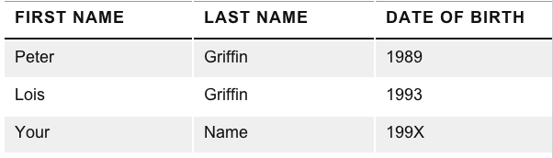

CAN YOU GET THE “DATES” COLUMN TO ALIGN ALL DATES TO THE RIGHT?

<body>
<table>
<tr>
<td>Peter</td>
<td>Griffin</td>
<td>1989</td>
</tr>
<tr>
<td>Lois</td>
<td>Griffin</td>
<td>1993</td>
</tr>
<tr>
<td>Your</td>
<td>Name</td>
<td>199X</td>
</tr>
</table>

</body>
</html>

